

5/30/2014

Re: NPA 346 to Overlay NPAs 281/713/832 (Texas)

Dear Customer,

On April 25, 2013 the Public Utilities Commission of Texas, in Project No. 22066, approved an
all services overlay and the implementation dates shown below as the relief method for the 281-
713-832 NPA Overlay complex. The 281-713-832 NPA overlay complex generally covers the
greater Houston area including portions of Harris, Fort Bend, Waller, Austin, Montgomery, San
Jacinto, Liberty, Chambers, Galveston and Brazoria counties. The new 346 NPA will serve the
same geographic area currently served by the existing 281-713-832 NPA.

Because 10-digit dialing already exists in the overlay complex, there is no permissive dialing
period. Implementation of the New 346 NPA overlay is as follows:

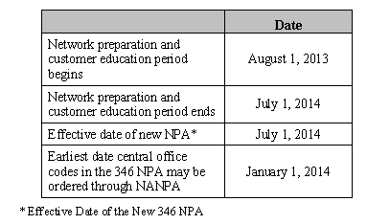

Mandatory Dialing Date Begins July 1st, 2014 - All callers must dial local calls with 10 digits. If you inadvertently dial 7 digits, your call will not be completed and a recording will prompt you to hang up and dial again.

Dialing Plan
Since mandatory 10-digit dialing is already in place, the dialing plan for the 281, 713, 832 and
346 NPAs is as follows:

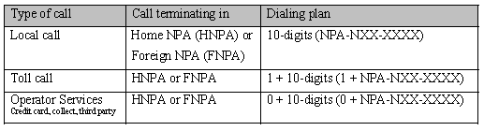

The area code overlay will not affect the cost of a call. Costs incurred for updating systems and revising printed materials is the responsibility of the customer. The directory listings (white pages) will be updated by the telecommunications industry. Listings appearing in other directories will be the responsibility of the customer.

General questions regarding the relief of the 281-713-832-346 NPA overlay should be directed
to Joe Cocke, Senior NPA Relief Planner NANPA, on 805-520-1945. Questions of a technical
nature should be directed to the NPA coordinator of the appropriate service provider.

